**Prerequisite :**

**Software :**

* **Node**
* **Git**
* **Webstorm IDE**

**1.GIT Install :**

Install Git and set path :

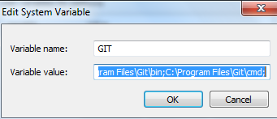

**Creating a New Project In GIT:**

1.Open git.tecnotree.com link

<http://git.tecnotree.com/>

2. create new Project :



Enter a project Name and clik on New Project

It will create a project. But we may get an warning message for SSH key



TO generate SSH Key follow the below Steps

Open git-bash , under :\Program Files\Git.

An SSH key allows you to establish a secure connection between your computer and GitLab. Before generating an SSH key in your shell, check if your system already has one by running the following command:

cat ~/.ssh/id_rsa.pub

If you see a long string starting with ssh-rsa, you can skip the ssh-keygen step.

Note: It is a best practice to use a password for an SSH key, but it is not required and you can skip creating a password by pressing enter. Note that the password you choose here can't be altered or retrieved.

To generate a new SSH key, use the following command:

ssh-keygen -t rsa -C "$your_email"

This command will prompt you for a location and filename to store the key pair and for a password. When prompted for the location and filename, just press enter to use the default. If you use a different name, the key will not be used automatically.

Use the command below to show your public key:

cat ~/.ssh/id_rsa.pub

Copy-paste the key to the 'My SSH Keys' section under the 'SSH' tab in your user profile. Please copy the complete key starting with ssh-rsa and ending with your username and host.

To copy your public key to the clipboard, use the code below. Depending on your OS you'll need to use a different command:

**Windows:**

clip < ~/.ssh/id_rsa.pub

**Mac**:

pbcopy < ~/.ssh/id_rsa.pub

**GNU/Linux (requires xclip):**

xclip -sel clip < ~/.ssh/id_rsa.pub

Add SSH Key

Paste key and click on add key

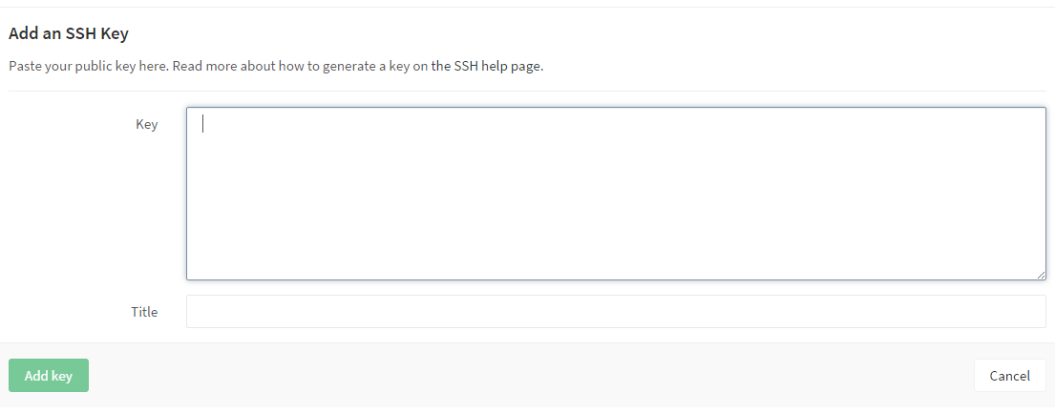

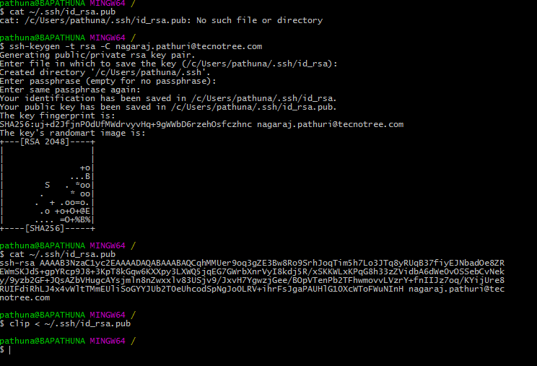

Clone Project into local machine :

Select https and copy URL

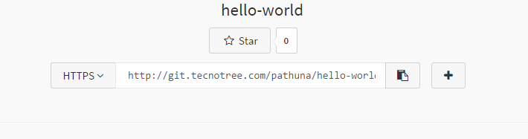

Open Command prompt

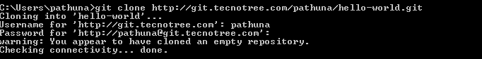

Goto project directory

Ex: C:\Users\pathuna>cd hello-world

Create html file inside the project

C:\Users\pathuna>touch hello-world.html

Or

Create html file under the project directory

Follow below commands to add file/commit project to git

* + git add “file name”
  + git commit –m “add filename”
  + git push –u origin master

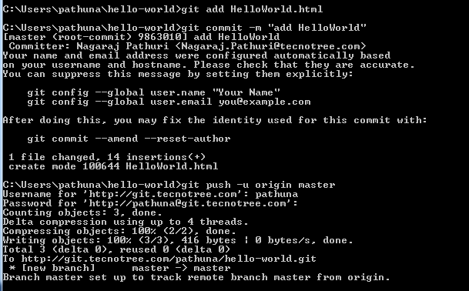

Pull Branch from git:

git clone -b CRA_Changes <https://git.tecnotree.com/selfcare/OLRWebUi.git>

git clone -b my-branch https://git@github.com/username/myproject.git

Create a branch in a git for master(project)

:> git branch

It will list out the all the branches

:> git branch branch <branchName> This command will create branch

Or

:> git checkout –b <branchName> this command will create a new branch and point to the create branch

:> git checkout <branch Name> this command will checkout the branch

08/02/2016 :

Some Sample Videos to learn Angular JS.

<https://www.codeschool.com/courses/shaping-up-with-angular-js>

12/02/2016:

Pre

Node.js

Git

Clone project OLR :

:>Git clone <Project URl>

Change the path to Project

:>npm install

Build project

Install webpack if it is not installed in System.

:> npm install webpack -g

:>npm run build-win

To start server :

:> npm run start-win